- Launch one EC2 using Amazon Linux 2 image and add a script in user data to install Apache.
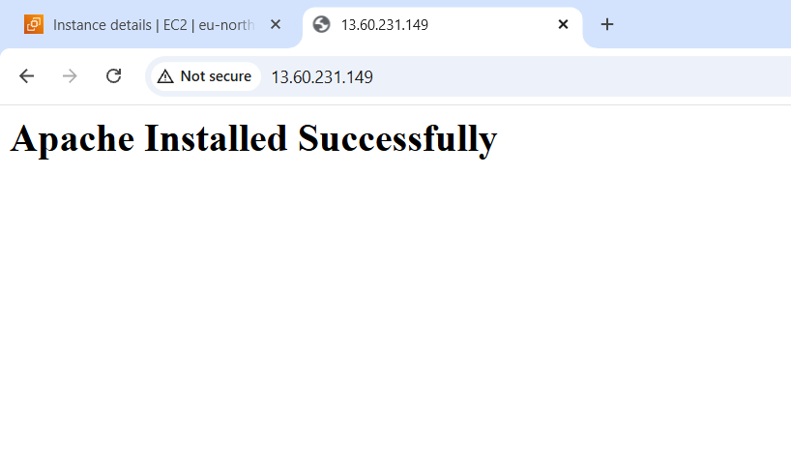

2. Launch one EC2 using Ubuntu image and add a script in user data to install Nginx.
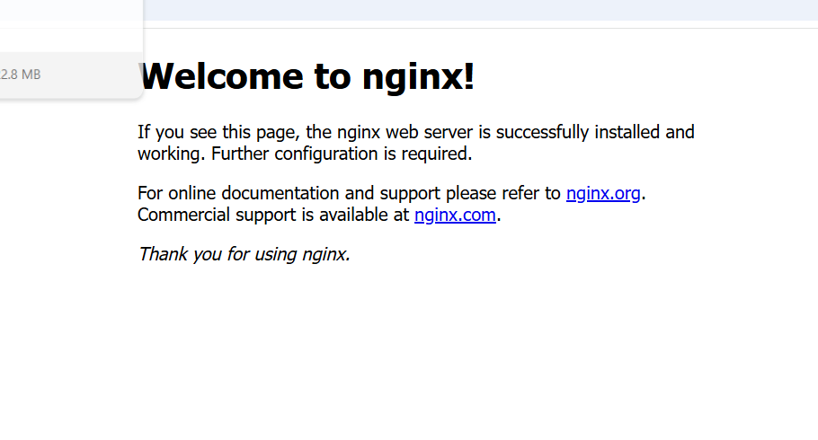

- Launch one Windows server and install Tomcat on Windows.



Installed tomcat 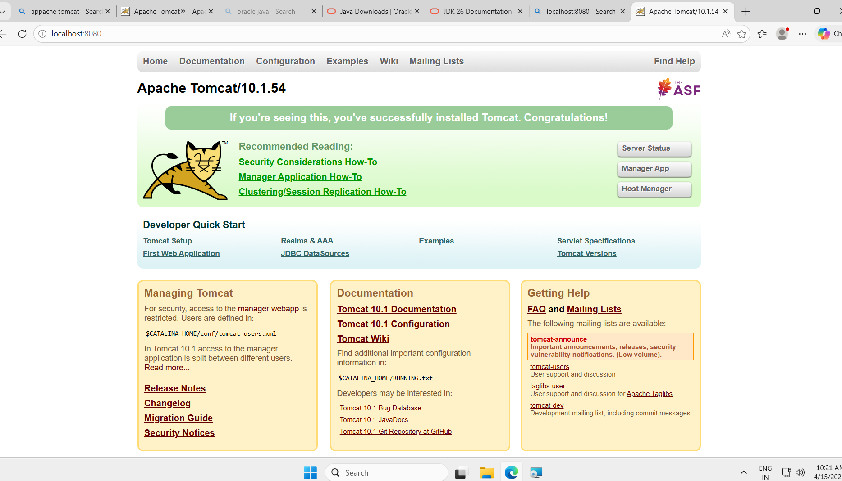

- Take a snapshot of the instance created in Task 1.

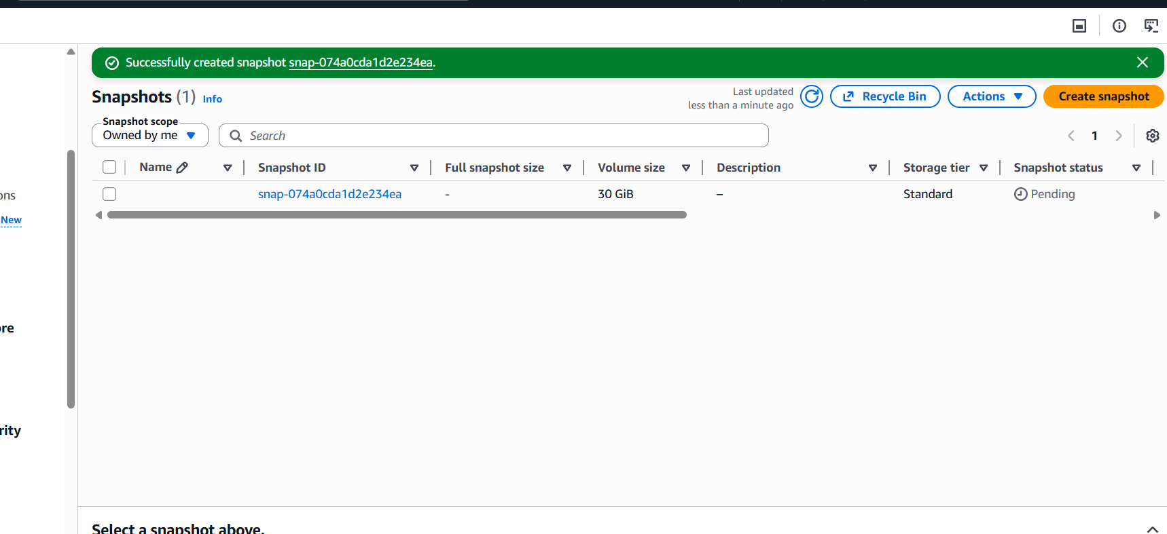

- Assign passwordless authentication for the EC2 created in Task

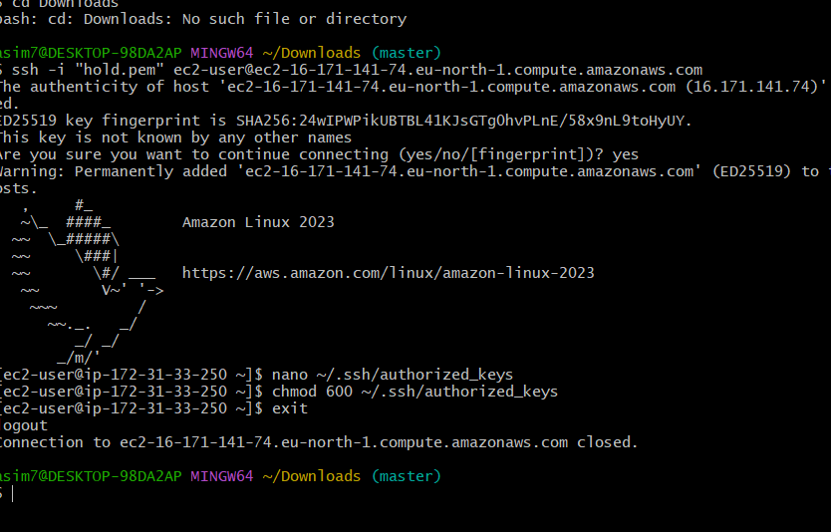

- Launch any EC2 using the spot purchasing option.

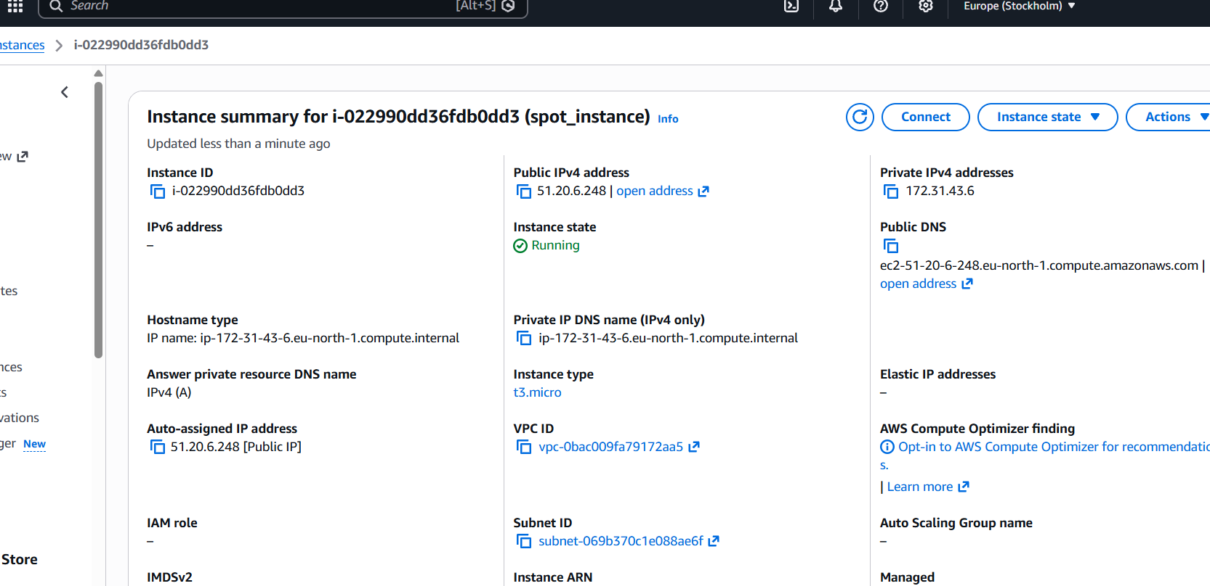

- Enable termination policy on the EC2 created in Task 2.

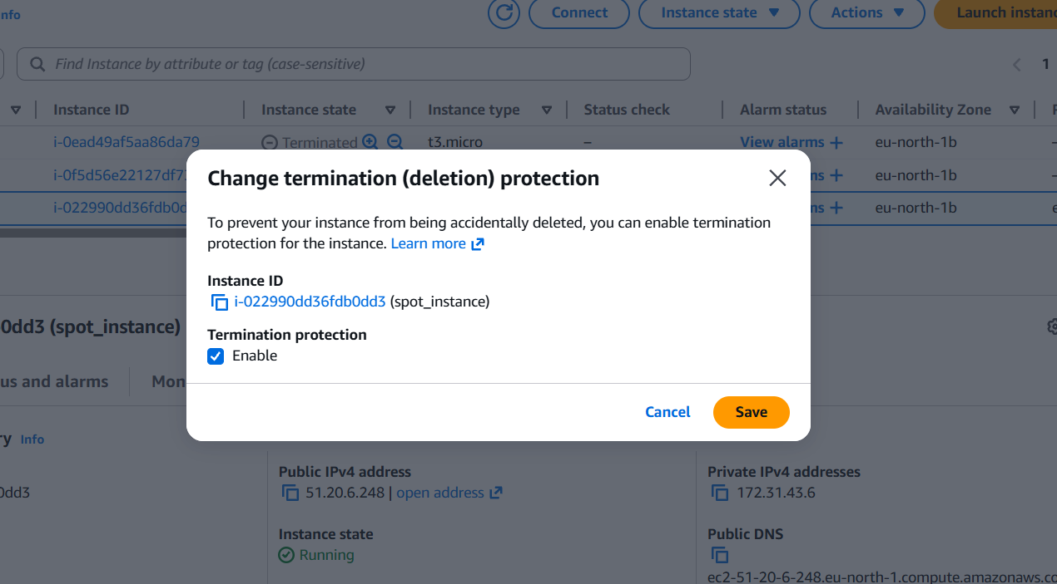

8. Launch one EC2 using AWS CLI.

